SEMESTER TWO
Papers written by
Australian Maths
Software

YEAR 12, Unit 3-4

MATHEMATICS APPLICATIONS
REVISION 3
2016

Section One
(Calculator–free)

Name: _________________________________

Teacher: ________________________________

TIME ALLOWED FOR THIS SECTION

Reading time before commencing work: 5 minutes
Working time for section: 50 minutes

MATERIAL REQUIRED / RECOMMENDED FOR THIS SECTION

To be provided by the candidate
Standard items: pens, pencils, pencil sharpener, highlighter, eraser, ruler.

IMPORTANT NOTE TO CANDIDATES
No other items may be taken into the examination room. It is your responsibility to ensure
that you do not have any unauthorised notes or other items of a non–personal nature in the
examination room. If you have any unauthorised material with you, hand it to the supervisor
before reading any further.

To be provided by the supervisor

Question/answer booklet for Section One.
A formula sheet which may also be used for Section Two.
Structure of this examination

 | Number of questions available | Number of questions to be answered | Working time (minutes) | Marks available | Percentage of exam
Section One  Calculator—free | 6 | 6 | 50 | 52 | 35
Section Two  Calculator—assumed | 10 | 10 | 100 | 98 | 65
Total marks |  |  |  | 150

Instructions to candidates

1. The rules for the conduct of this examination are detailed in the Information
Handbook. Sitting this examination implies that you agree to abide by these rules.

2. Write your answers in the Question/Answer booklet.

3. You must be careful to confine your responses to the specific questions asked and to
follow any instructions that are specific to a particular question.

4. Spare pages are provided at the end of this booklet. If you need to use them, indicate
in the original answer space where the answer is continued i.e. give the page number.

5. Show all your working clearly. Your working should be in sufficient detail to allow your
answers to be checked readily and for marks to be awarded for reasoning. Incorrect
answers given without supporting reasoning cannot be allocated any marks. For any
question or part question worth more than two marks, valid working or justification is
required to receive full marks. If you repeat an answer to any question, ensure that you
cancel the answer you do not wish to have marked.

6. It is recommended that you do not use pencil, except in diagrams.

7. The Formula Sheet is not to be handed in with your Question/Answer booklet.

1. (4 marks)
Describe the association between the two variables that are graphed in the
scatter diagrams below.

(a) (2)
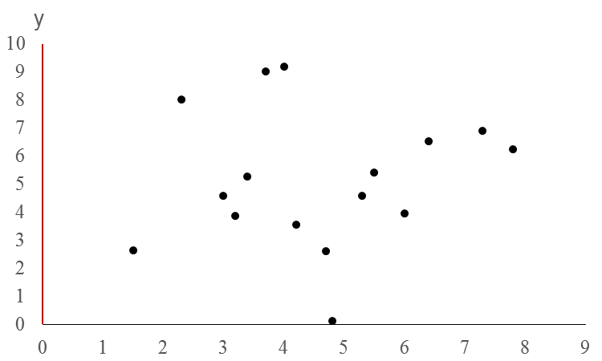

(b) (2)
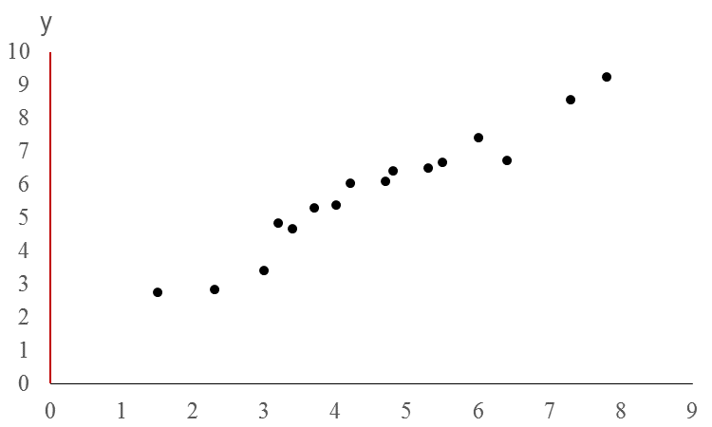
x
2. (14 marks)
(a) Consider the sequence list in the table below:
 | 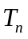
1 | 13
2 | 15
3 | 17
4 | 19

(i) Define the sequence recursively. (2)

(ii) Define the sequence in terms of . (2)

(iii) Determine if 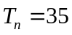. (2)
(b) The first three terms of a sequence is graphed on the set of axes below.
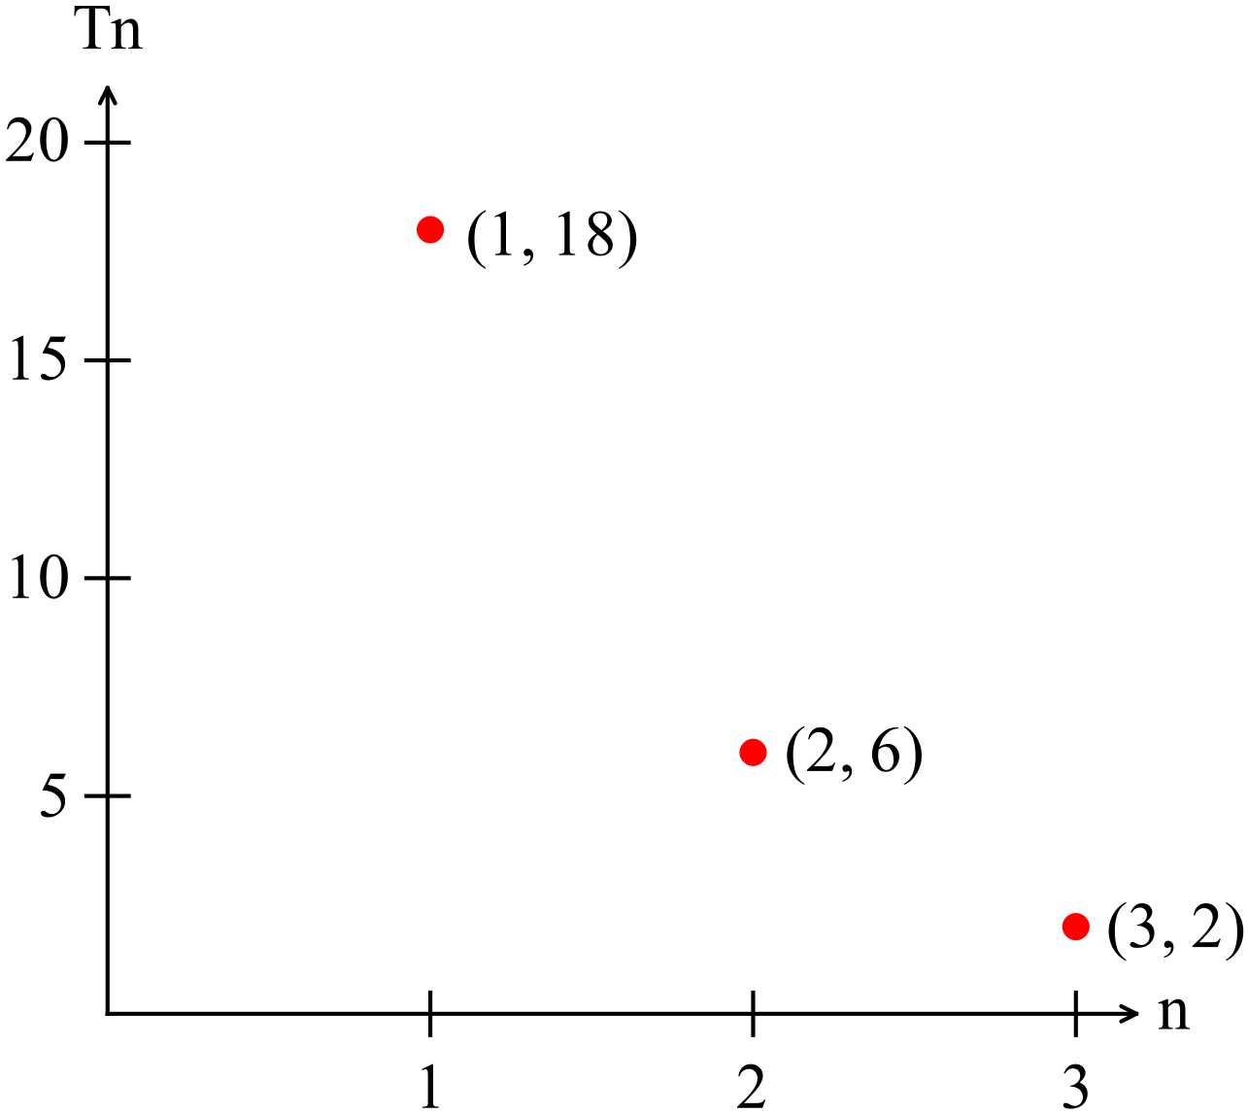
(i) Explain, with reference to the graph, why the sequence must be a
geometric progression rather than an arithmetic progression. (3)

(ii) Define the sequence recursively. (2)

(c) A sequence is defined as 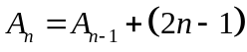. Given 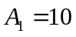, find 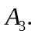 (3)

3. (8 marks)

(a) Construct a closed network that has 6 arcs and 5 vertices. (3)

(c) (i) Draw a complete graph that has four vertices and state the number of
regions and edges. (3)

(ii) Show that Euler’s Rule works for this graph. (2)

4. (5 marks)

Small towns on the Nullarbor want to improve their water supply. The old pipes tend to deteriorate given the hardness and impurities in the water. They intend building a new system with a much better quality pipe.

(a) Given the distances (kms) shown on the network below, determine the minimum
spanning tree and shade it on the network. (3)

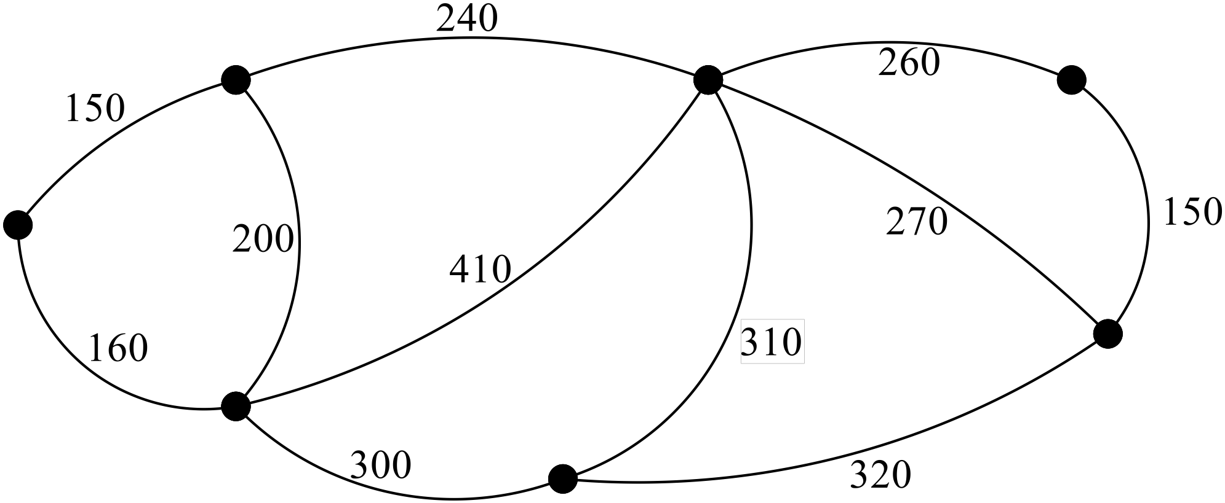

(b) What is the total length of water piping needed? (2)

5. (14 marks)

Dean has decided to build a garden shed.
The activities, their immediate predecessors and duration in hours are shown in the table below.
Task | Immediate Predecessors | Duration (hours)
A Design the shed | - | 1
B Clear the garden | - | 3
C Buy the materials | A | 1
D Build the shed base and place in position | B, C | 2
E Mix the cement for the shed base. | B, C | 0.5
F Pour the cement base and wait til it hardens | D, E | 24
G Cut the wood | B, C | 3
H Assembly the shed | F | 4
J Build the tin roof | H | 2
K Paint the shed (including the roof) | J | 3
L Shed is finished

(a) Construct a project network given the following tasks, predecessors and the
duration of each task.
Mark in each duration. (5)

(b) Shade the critical path. (2)

(c) What is the minimum completion time? (1)

(d) Task G has Task C as an immediate predecessor.
How long can task G be delayed before it affects the minimum completion
time? (2)

(e) State where any the float time occurs. (2)

Dean’s wife needed help inside the house and he had to delay mixing the cement for two hours.
(f) How does this delay affect the minimum completion time of completing his
garden shed? (2)

6 (7 marks)
Consider the directed network below

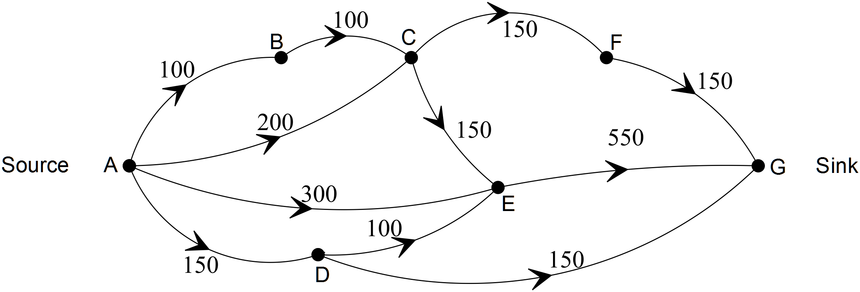

(a) Using a systematic approach by listing all paths and their carrying capacity, determine the maximum flow from the source to the sink. (4)

(b) How much would the maximum flow be reduced if CE was blocked? (2)

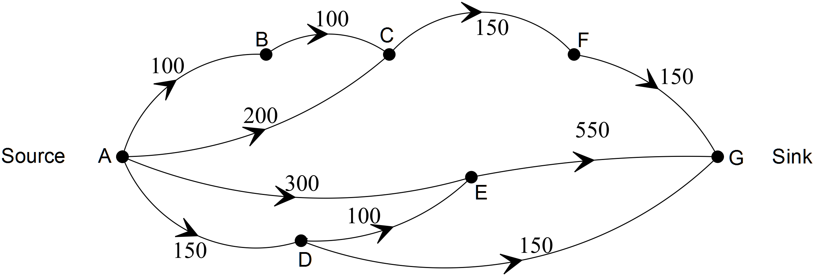

(c) If no paths were blocked, what path would you increase and by how much to
increase the flow to a maximum? (1)

END OF SECTION ONE

